- Create new Workspace
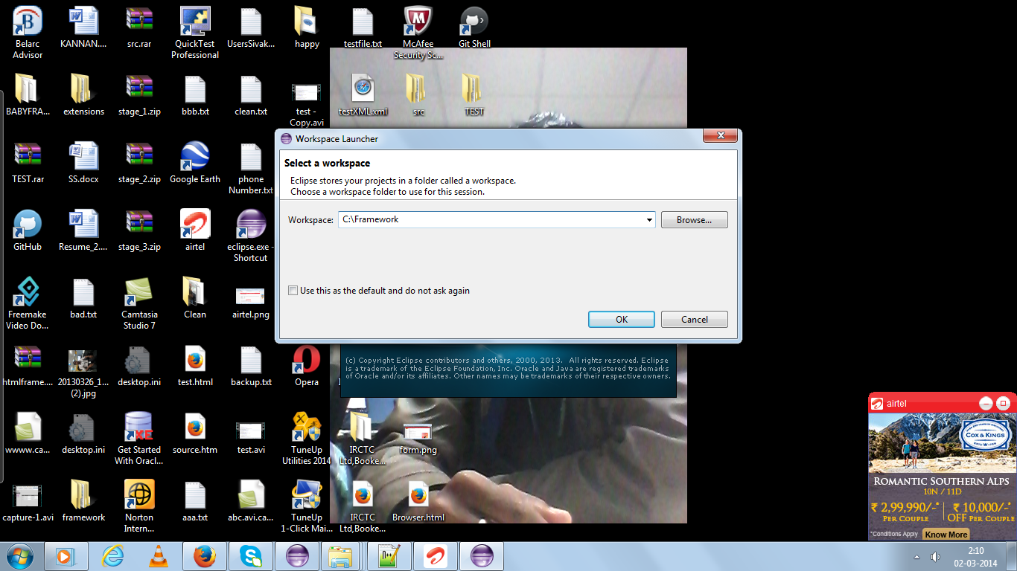
- Go to File->New->JavaProject
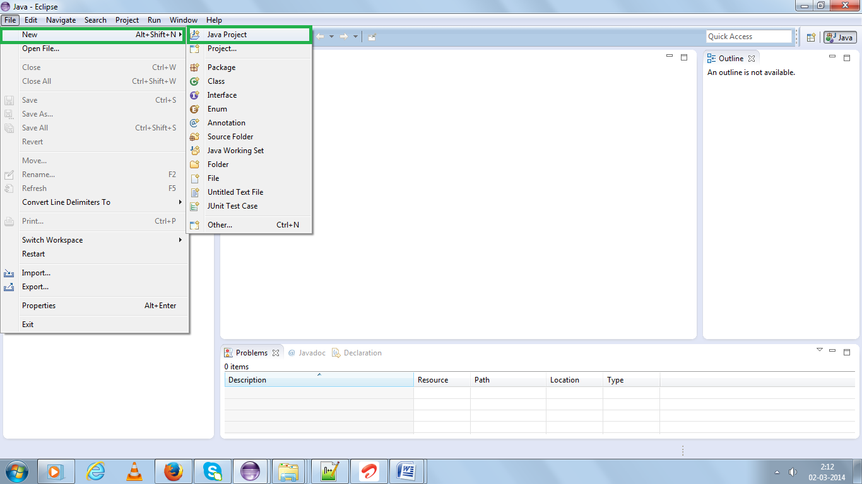
- Deselect check box

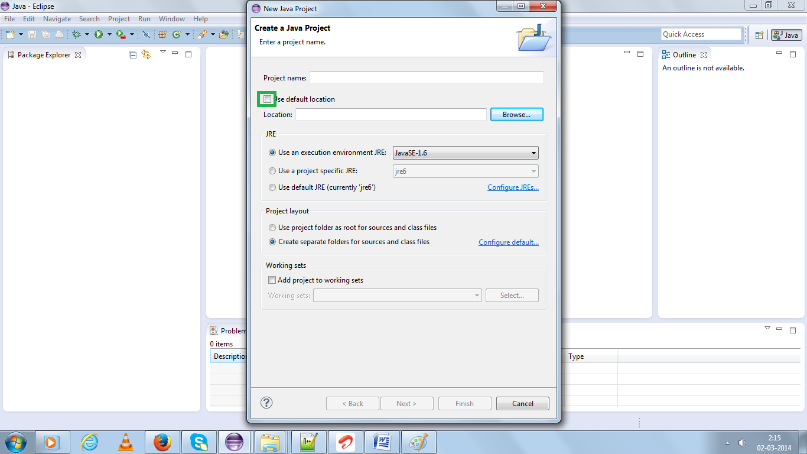
- Click Browse button and select “BABYFRAMEWORK-II” , then click OK button (Download BABYFRAMEWORK-II .zip and extract it.)
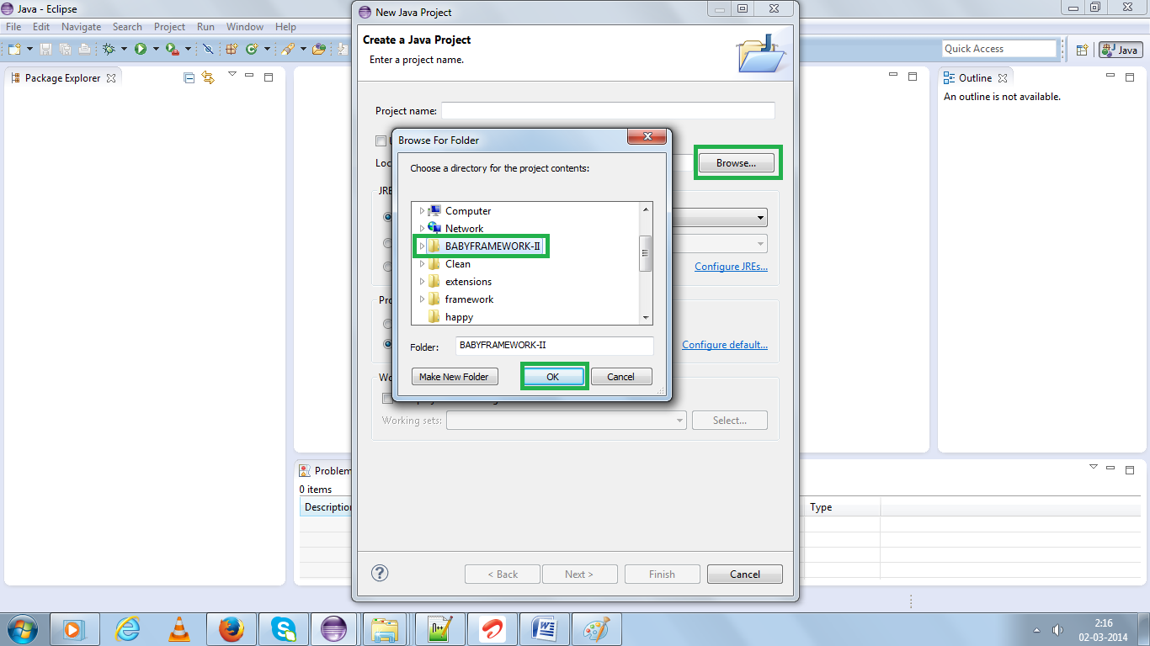
- Click Finish Button
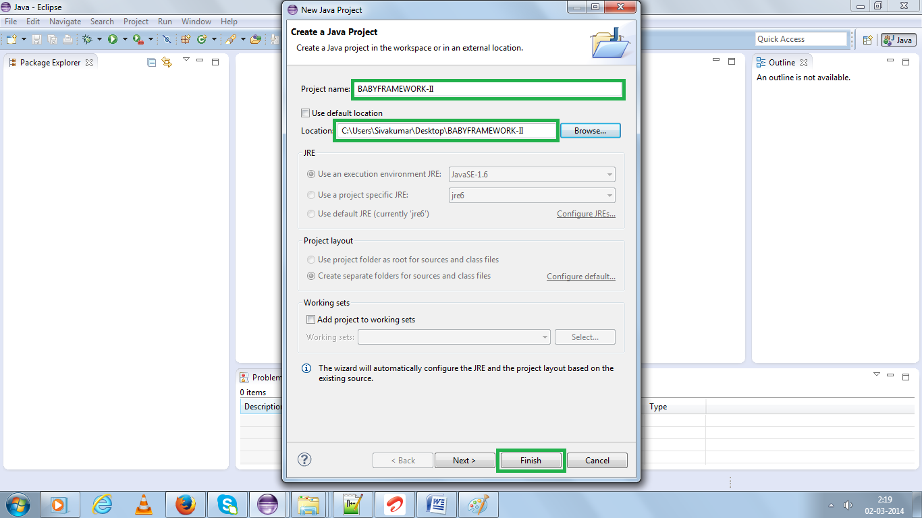
- Now You can see the entire Framework structure Left hand side
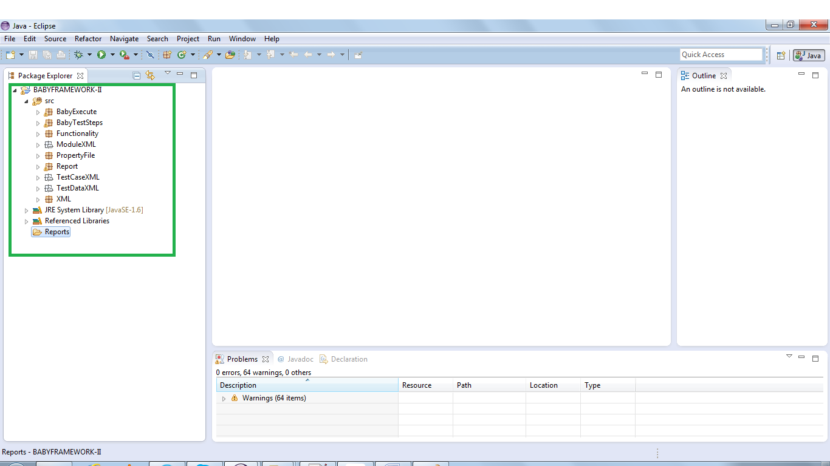
- i) Download selenium Jar for java
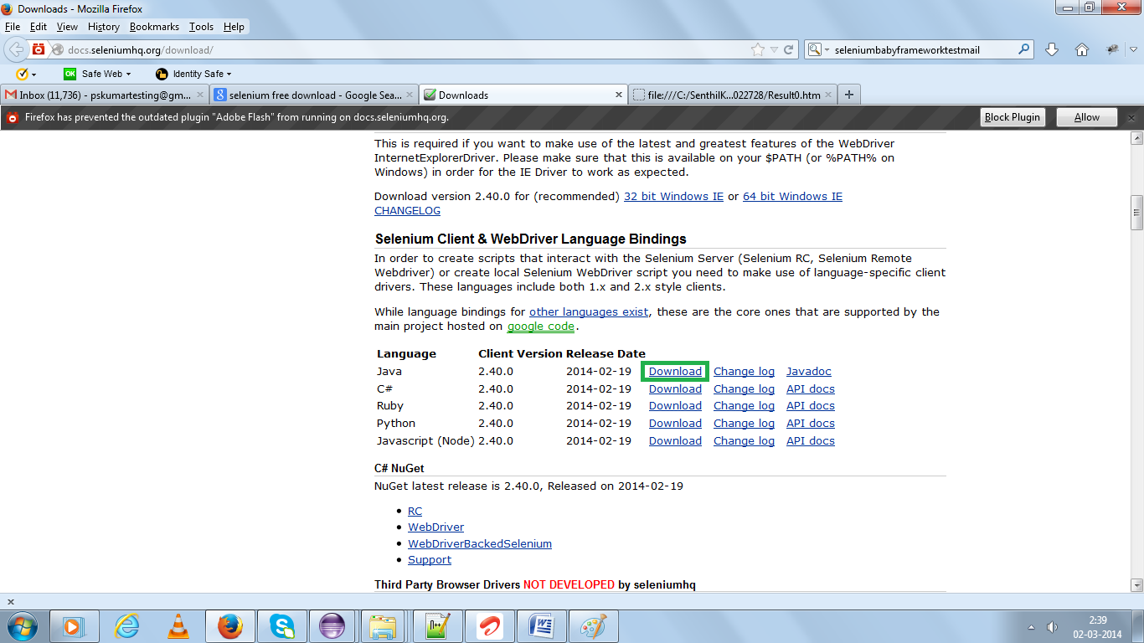
ii) Extract the entire jar and right click framework and go to BuildPath→Configurebuild path
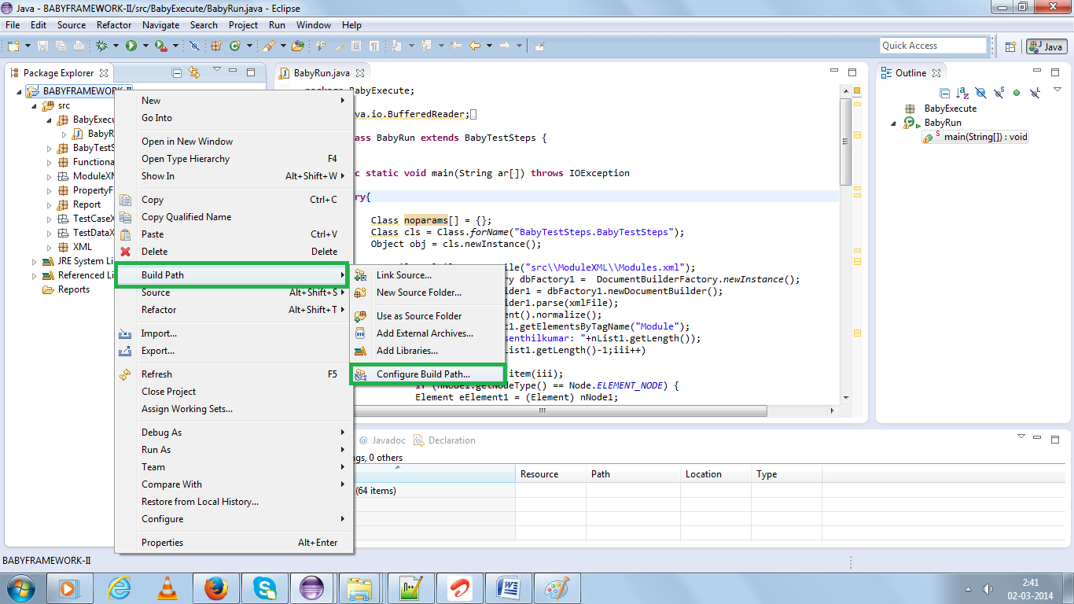
iii) Click libraries tab and click “Add External JARs” select the entire extracted jars. Click Open and click “OK”
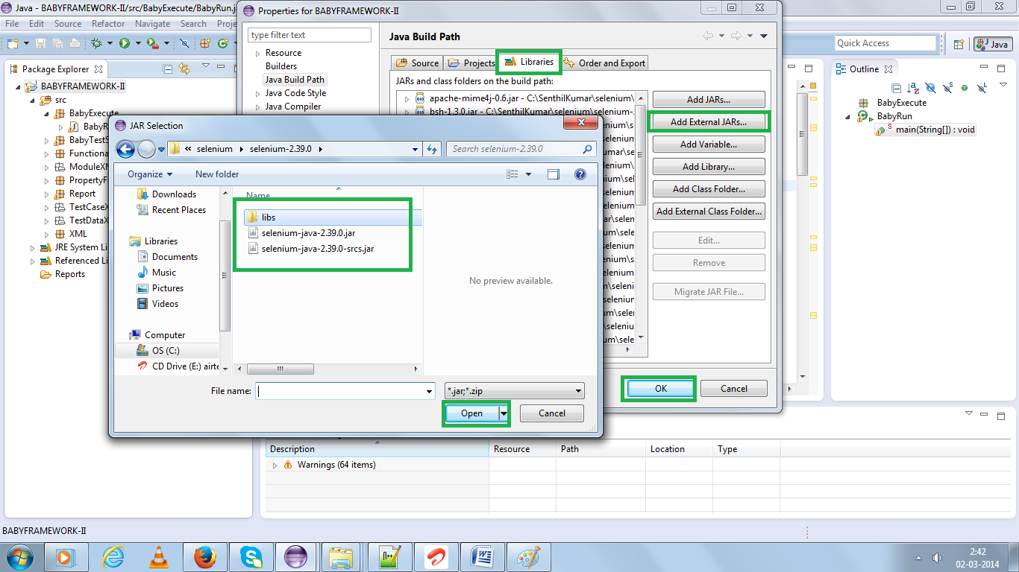
- Run “BabyRun.java” file (Run As→Java Application)
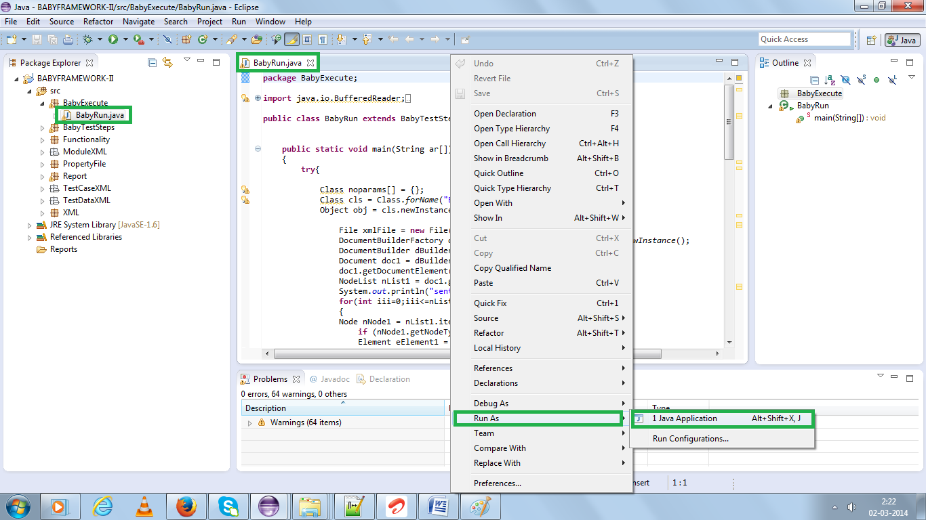
- Now Selenium start the execution
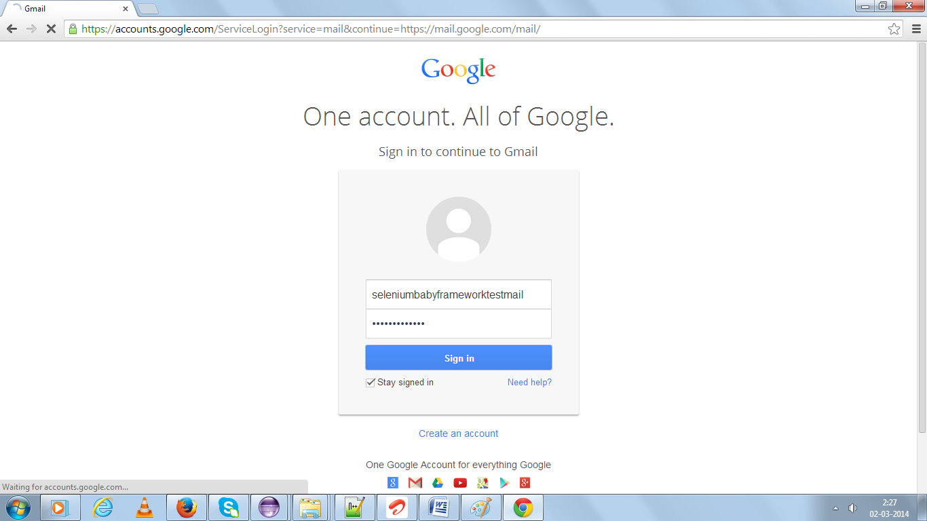
- Once the execution completed you will get the auto generated HTML report(If any steps fail it will take the Screen shots aswell and All the reports are store under //BABYFRAMEWORK-II //Reports path)
